LIMKOKWING UNIVERSITY OF CREATIVE TECHNOLOGY
Department of Information & Communications Technology

PROG209 — EVENT DRIVEN PROGRAMMING
BASIC INTERACTIVE GUI
Individual Assignment Report

Student: Mohamed Barry
Lecturer: Amandus Benjamin Coker
Academic Session: September 2026 – February 2027
Submission: Week 4
GitHub Repository: https://github.com/Sensationalbilly/JAVASWING-ASSIGNMENT

Table of Contents
Introduction
Aim and Objectives
Design and Figma Wireframe
Application Development
Inheritance and Constructors
Event-Driven Functionality
Application Testing
Implementation Evidence
GitHub Repository and Submission
Conclusion
Appendix A — BaseWindow.java
Appendix B — SwingAssignment.java

Introduction
This report documents the design and implementation of a basic interactive desktop graphical user interface (GUI) developed in Java Swing for the PROG209 Event Driven Programming individual assignment. The application presents a welcome message, a custom coffee-cup application icon, two interactive buttons, and course information within a styled desktop window. The interface was planned in Figma before implementation in Java.
The application demonstrates the relationship between Swing containers and components, class inheritance, constructors, and event handling. Its design follows the submitted Figma wireframe while keeping the program understandable and suitable for an introductory Java assignment.

Aim and Objectives
The aim is to design and implement a functional Java Swing application that satisfies the assignment requirements and demonstrates basic event-driven programming concepts.
- Create an 800 × 800 JFrame titled “Java Swing Assignment”.
- Instantiate and use a JPanel and a JLabel with the required welcome text.
- Demonstrate inheritance and constructor chaining through two related classes.
- Use ImageIcon with an original application icon.
- Provide buttons that change the JLabel text and JPanel background color.
- Document the Figma wireframe, implementation, and functional testing.

Design and Figma Wireframe
The initial interface was designed in Figma using an annotated wireframe. It identifies the JFrame, JPanel, JLabel, ImageIcon, and JButton components. The visual design uses a navy header and footer with curved waves, a centered coffee-cup emblem, prominent welcome text, and two color-coded controls. The wireframe includes the specified 800-pixel width and height.
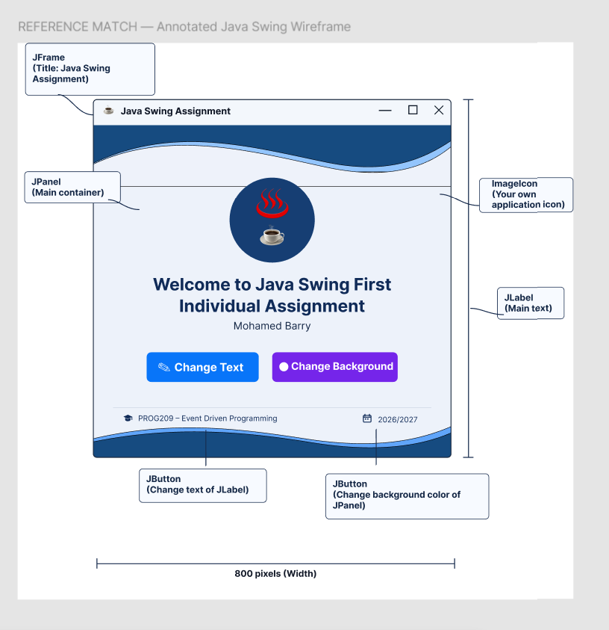
Figure 1. Annotated Figma wireframe used as the design reference.
Figma design: https://www.figma.com/design/oj77XouchSLTbLLJTI17lV

Application Development
The application is implemented in Java with the Swing and AWT libraries. The main window is represented by a JFrame. A JPanel using BorderLayout contains a decorative header, a central content region, and a decorative footer. The central content uses BoxLayout and additional panels to align the application icon, welcome message, buttons, and course details.
Component | Purpose in the application
JFrame | Top-level desktop window; title, size, and close behavior.
JPanel | Holds and organizes the visual components.
JLabel | Displays the welcome text and application imagery.
ImageIcon | Loads the custom window icon and displays the large central image.
JButton | Provides the Change Text and Change Background actions.
ActionListener | Responds to clicks and updates the interface.
The custom wave banner and rounded buttons are painted using Java2D. The original icon is drawn programmatically and saved as assets/icon.png, then loaded through ImageIcon. The program also draws the graduation-cap and calendar symbols shown in the footer.

Inheritance and Constructors
Inheritance is demonstrated by the declaration “public class SwingAssignment extends BaseWindow”. BaseWindow extends JFrame and defines shared fields, colors, icon rendering, and basic window configuration. SwingAssignment inherits those capabilities and adds the assignment-specific interface and behavior.
The BaseWindow(String title) constructor sets the window title, size (800 × 800), EXIT_ON_CLOSE behavior, centered positioning, and application icon. The SwingAssignment() constructor calls super("Java Swing Assignment"), builds the interface, and makes the window visible. This demonstrates constructor chaining: the parent constructor executes before the child completes initialization.

Event-Driven Functionality

Change Text
The Change Text button has an ActionListener. Each click advances an index through an array of predefined messages and updates the existing JLabel using setText(...). Repeated clicks cycle through the available messages.

Change Background
The Change Background button has an ActionListener that cycles through predefined background colors. The applyBackground(...) method updates the main JPanel and central content area, then requests a repaint. The header and footer retain their decorative styling.

Close Window
The JFrame uses EXIT_ON_CLOSE, so selecting the native X control closes the application. The standard window controls are supplied by the operating system rather than manually drawn in the Java content area.

Application Testing
I ran the application locally and confirmed that the interactive actions worked as expected. The following table records the reported results; these are manual observations, not automated unit-test results.
Test performed | Reported result
Click Change Text | Pass — welcome text changes.
Click Change Background | Pass — background color changes.
Click X in the title bar | Pass — application closes.

Implementation Evidence
The following screenshot shows the running Java Swing application. Unlike the annotated Figma wireframe, this is the executable desktop interface produced from the Java source files.
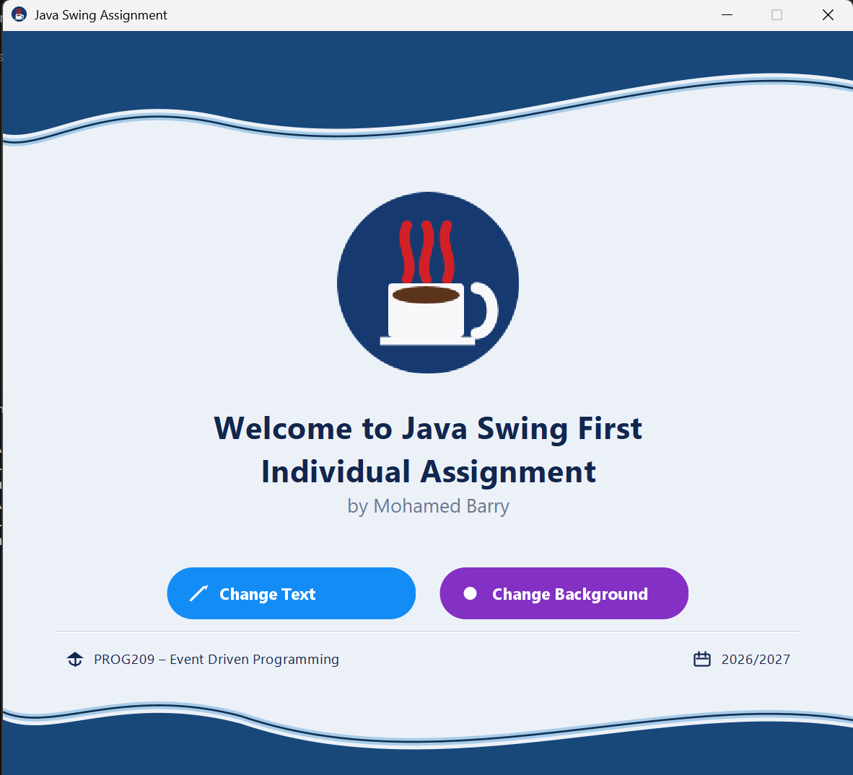
Figure 2. Running Java Swing application showing the implemented interface.

GitHub Repository and Submission
The source files should be committed to a GitHub repository, with the lecturer added as a collaborator in accordance with the assignment instructions. Before submission, replace the placeholder below with the actual repository URL and verify that all required source and asset files are present.
Repository URL: https://github.com/Sensationalbilly/JAVASWING-ASSIGNMENT
Recommended repository contents: src/BaseWindow.java, src/SwingAssignment.java, assets/icon.png, README.md, and an appropriate .gitignore. Compiled .class files and local IDE configuration folders are not needed for source-code assessment.

Conclusion
The project demonstrates the creation of a functional Java Swing GUI from an initial Figma design. It includes the required window, panel, label, image icon, inheritance, and constructors, and it responds to user actions through event listeners. The reported functional tests confirm that the text-change, background-change, and exit actions operate as intended. The completed application provides a practical introductory example of event-driven desktop programming.

Appendix A — BaseWindow.java
Complete source listing from the submitted project files. The code is reproduced here for review; the repository should contain the original editable .java file.
import javax.swing.*;
import java.awt.*;
import java.awt.geom.Ellipse2D;
import java.awt.geom.GeneralPath;
import java.awt.geom.RoundRectangle2D;
import java.awt.image.BufferedImage;
import java.io.File;
import javax.imageio.ImageIO;

/**
* BaseWindow is the parent / base class for the application window.
*
* It creates the JFrame, sets the required window properties, and
* prepares shared colours used by the child class.
*
* SwingAssignment inherits from this class (inheritance) and calls
* this constructor with super(...) (constructor chaining).
*/
public class BaseWindow extends JFrame {

// Required by the assignment: a JFrame variable named frame
protected JFrame frame;

// Required by the assignment: a JPanel variable named panel
protected JPanel panel;

// Required by the assignment: a JLabel variable named label
protected JLabel label;

// Colour palette taken from the Figma wireframe
protected static final Color BG_LIGHT = new Color(236, 241, 248);
protected static final Color NAVY = new Color(24, 72, 122);
protected static final Color WAVE_ACCENT = new Color(168, 204, 232);
protected static final Color CIRCLE_NAVY = new Color(22, 58, 112);
protected static final Color TEXT_DARK = new Color(18, 38, 78);
protected static final Color TEXT_MUTED = new Color(105, 118, 145);
protected static final Color BTN_BLUE = new Color(20, 140, 245);
protected static final Color BTN_PURPLE = new Color(132, 48, 196);
protected static final Color DIVIDER = new Color(200, 210, 222);
protected static final Color CUP_CREAM = new Color(248, 248, 250);
protected static final Color COFFEE_BROWN = new Color(92, 52, 28);
protected static final Color STEAM_RED = new Color(210, 32, 38);

/**
* Constructor: sets up the main window.
*
* @param title text shown in the JFrame title bar
*/
public BaseWindow(String title) {
super(title);

// Assignment requirements: 800 x 800 and close the app on exit
this.setSize(800, 800);
this.setDefaultCloseOperation(JFrame.EXIT_ON_CLOSE);
this.setLocationRelativeTo(null);
this.setResizable(false);

// The assignment asks for a JFrame variable named frame
this.frame = this;

loadIcon();
}

/**
* Loads (or creates) the application icon from the assets folder
* using ImageIcon, then applies it to the JFrame.
*/
private void loadIcon() {
File iconFile = new File("assets/icon.png");
iconFile.getParentFile().mkdirs();

try {
ImageIO.write(createCoffeeIcon(64), "png", iconFile);
} catch (Exception e) {
System.err.println("Could not save icon: " + e.getMessage());
}

try {
this.setIconImage(new ImageIcon(iconFile.getAbsolutePath()).getImage());
} catch (Exception e) {
System.err.println("Could not load icon: " + e.getMessage());
}
}

/**
* Draws a small circular coffee-cup icon used as the window icon.
*/
private BufferedImage createCoffeeIcon(int size) {
BufferedImage img = new BufferedImage(size, size, BufferedImage.TYPE_INT_ARGB);
Graphics2D g = img.createGraphics();
g.setRenderingHint(RenderingHints.KEY_ANTIALIASING, RenderingHints.VALUE_ANTIALIAS_ON);
drawCoffeeBadge(g, 0, 0, size);
g.dispose();
return img;
}

/**
* Shared drawing routine for the circular coffee badge.
* Used both for the window icon and the large centre icon.
*/
protected void drawCoffeeBadge(Graphics2D g, int x, int y, int size) {
g.setColor(CIRCLE_NAVY);
g.fill(new Ellipse2D.Double(x, y, size, size));

int cupW = (int) (size * 0.42);
int cupH = (int) (size * 0.30);
int cupX = x + (size - cupW) / 2 - 2;
int cupY = y + (int) (size * 0.50);

// Steam
g.setColor(STEAM_RED);
g.setStroke(new BasicStroke(Math.max(2f, size / 18f),
BasicStroke.CAP_ROUND, BasicStroke.JOIN_ROUND));
int[] steamXs = {
cupX + cupW / 4,
cupX + cupW / 2,
cupX + (int) (cupW * 0.78)
};
for (int i = 0; i < steamXs.length; i++) {
int sx = steamXs[i];
GeneralPath steam = new GeneralPath();
int base = cupY - 4;
int top = y + (int) (size * 0.18);
int mid = (base + top) / 2;
int dir = (i == 1) ? -1 : 1;
steam.moveTo(sx, base);
steam.curveTo(sx + dir * 8, mid + 6, sx - dir * 8, mid - 6, sx, top);
g.draw(steam);
}

// Cup body
g.setColor(CUP_CREAM);
g.fill(new RoundRectangle2D.Double(cupX, cupY, cupW, cupH, 8, 8));

// Coffee surface
g.setColor(COFFEE_BROWN);
g.fillOval(cupX + 4, cupY + 3, cupW - 8, cupH / 3);

// Handle
g.setStroke(new BasicStroke(Math.max(2.5f, size / 16f),
BasicStroke.CAP_ROUND, BasicStroke.JOIN_ROUND));
g.setColor(CUP_CREAM);
g.drawArc(cupX + cupW - 4, cupY + 4, (int) (size * 0.18), cupH - 8, 270, 180);

// Saucer
g.setStroke(new BasicStroke(Math.max(2f, size / 22f)));
g.drawLine(cupX - 4, cupY + cupH + 3, cupX + cupW + 6, cupY + cupH + 3);
}
}

Appendix B — SwingAssignment.java
Complete source listing from the submitted project files. The code is reproduced here for review; the repository should contain the original editable .java file.
import javax.swing.*;
import java.awt.*;
import java.awt.event.ActionEvent;
import java.awt.event.ActionListener;
import java.awt.event.MouseAdapter;
import java.awt.event.MouseEvent;
import java.awt.geom.Ellipse2D;
import java.awt.geom.Path2D;
import java.awt.image.BufferedImage;

/**
* SwingAssignment is the main class for this PROG209 assignment.
*
* Inheritance:
* SwingAssignment extends BaseWindow, so it reuses the JFrame setup,
* colours, and icon drawing from the parent class.
*
* Constructor:
* The constructor below calls super(...) first, then builds the GUI.
*
* Event driven programming:
* Each button has an ActionListener that runs when the button is clicked.
*
* Author: Mohamed Barry
*/
public class SwingAssignment extends BaseWindow {

// Texts shown when the Change Text button is clicked
private static final String[] LABEL_TEXTS = {
"Welcome to Java Swing First Individual Assignment by Mohamed Barry",
"Java Swing — Event Driven Programming",
"PROG209 — Assignment by Mohamed Barry",
"Hello from SwingAssignment!"
};
private int labelTextIndex = 0;

// Background colours shown when the Change Background button is clicked
private static final Color[] BG_COLORS = {
BG_LIGHT,
new Color(220, 245, 232),
new Color(245, 228, 246),
new Color(255, 240, 220)
};
private int bgColorIndex = 0;

// Centre area (icon, heading, buttons, footer info)
private JPanel centrePanel;
private JPanel buttonRow;
private JPanel infoRow;

/**
* Constructor for the child class.
* super(...) runs the BaseWindow constructor first.
*/
public SwingAssignment() {
super("Java Swing Assignment");
buildUI();
frame.setVisible(true);
}

/**
* Builds the full window layout to match the Figma wireframe:
* navy wave header, centred content, info bar, navy wave footer.
*/
private void buildUI() {
panel = new JPanel(new BorderLayout());
panel.setBackground(BG_LIGHT);
frame.setContentPane(panel);

panel.add(new WaveBanner(true), BorderLayout.NORTH);

centrePanel = buildCentre();
panel.add(centrePanel, BorderLayout.CENTER);

panel.add(new WaveBanner(false), BorderLayout.SOUTH);
}

/**
* Creates the middle of the window: coffee icon, welcome label,
* two action buttons, and the course / year information.
*/
private JPanel buildCentre() {
JPanel centre = new JPanel();
centre.setLayout(new BoxLayout(centre, BoxLayout.Y_AXIS));
centre.setBackground(BG_LIGHT);
centre.setBorder(BorderFactory.createEmptyBorder(10, 50, 8, 50));

centre.add(Box.createVerticalGlue());

JLabel iconLabel = new JLabel(new ImageIcon(renderCentreIcon(168)));
iconLabel.setAlignmentX(Component.CENTER_ALIGNMENT);
centre.add(iconLabel);

centre.add(Box.createVerticalStrut(28));

// Required JLabel — wrapped in a FlowLayout panel so BoxLayout centres it properly
label = new JLabel(formatWelcome(LABEL_TEXTS[0]), SwingConstants.CENTER);
JPanel labelWrapper = new JPanel(new FlowLayout(FlowLayout.CENTER, 0, 0));
labelWrapper.setOpaque(false);
labelWrapper.setAlignmentX(Component.CENTER_ALIGNMENT);
labelWrapper.add(label);
centre.add(labelWrapper);

centre.add(Box.createVerticalStrut(36));

buttonRow = buildButtonRow();
buttonRow.setAlignmentX(Component.CENTER_ALIGNMENT);
centre.add(buttonRow);

centre.add(Box.createVerticalGlue());

JSeparator line = new JSeparator();
line.setForeground(DIVIDER);
line.setMaximumSize(new Dimension(Integer.MAX_VALUE, 1));
centre.add(line);

centre.add(Box.createVerticalStrut(14));

infoRow = buildInfoRow();
infoRow.setAlignmentX(Component.CENTER_ALIGNMENT);
centre.add(infoRow);

centre.add(Box.createVerticalStrut(6));
return centre;
}

/**
* Formats the welcome heading so it looks like the Figma layout:
* large bold title, smaller grey author line underneath.
*/
private String formatWelcome(String text) {
String title = text;
String author = "";

if (text.contains(" by ")) {
int at = text.lastIndexOf(" by ");
title = text.substring(0, at);
author = "by " + text.substring(at + 4);
}

// Match the Figma two-line heading
title = title.replace("First Individual", "First<br>Individual");

return "<html><div style='text-align:center; width:640px;'>"
+ "<span style='font-family:Segoe UI; font-size:22px; font-weight:bold; color:#12264E;'>"
+ title
+ "</span>"
+ (author.isEmpty()
? ""
: "<br><span style='font-family:Segoe UI; font-size:14px; font-weight:normal; color:#697691;'>"
+ author + "</span>")
+ "</div></html>";
}

/** Draws the large circular coffee icon used in the centre of the window. */
private BufferedImage renderCentreIcon(int size) {
BufferedImage img = new BufferedImage(size, size, BufferedImage.TYPE_INT_ARGB);
Graphics2D g = img.createGraphics();
g.setRenderingHint(RenderingHints.KEY_ANTIALIASING, RenderingHints.VALUE_ANTIALIAS_ON);
drawCoffeeBadge(g, 0, 0, size);
g.dispose();
return img;
}

/**
* Creates the two event-driven buttons from the wireframe.
*/
private JPanel buildButtonRow() {
JPanel row = new JPanel(new FlowLayout(FlowLayout.CENTER, 22, 0));
row.setOpaque(false);
row.setMaximumSize(new Dimension(700, 58));

RoundedButton changeTextBtn = new RoundedButton("Change Text", BTN_BLUE, true);
changeTextBtn.addActionListener(new ActionListener() {
@Override
public void actionPerformed(ActionEvent e) {
// Event: Change Text was clicked → update the JLabel
labelTextIndex = (labelTextIndex + 1) % LABEL_TEXTS.length;
label.setText(formatWelcome(LABEL_TEXTS[labelTextIndex]));
}
});

RoundedButton changeBgBtn = new RoundedButton("Change Background", BTN_PURPLE, false);
changeBgBtn.addActionListener(new ActionListener() {
@Override
public void actionPerformed(ActionEvent e) {
// Event: Change Background was clicked → update the JPanel colour
bgColorIndex = (bgColorIndex + 1) % BG_COLORS.length;
applyBackground(BG_COLORS[bgColorIndex]);
}
});

row.add(changeTextBtn);
row.add(changeBgBtn);
return row;
}

/**
* Footer information from the Figma design, drawn on the light background
* (not on top of the navy wave).
*/
private JPanel buildInfoRow() {
JPanel row = new JPanel(new BorderLayout());
row.setOpaque(false);
row.setMaximumSize(new Dimension(Integer.MAX_VALUE, 28));

JPanel left = new JPanel(new FlowLayout(FlowLayout.LEFT, 8, 0));
left.setOpaque(false);
left.add(new JLabel(new CapIcon()));
JLabel course = new JLabel("PROG209 – Event Driven Programming");
course.setFont(new Font("Segoe UI", Font.PLAIN, 13));
course.setForeground(TEXT_DARK);
left.add(course);

JPanel right = new JPanel(new FlowLayout(FlowLayout.RIGHT, 8, 0));
right.setOpaque(false);
right.add(new JLabel(new CalendarIcon()));
JLabel year = new JLabel("2026/2027");
year.setFont(new Font("Segoe UI", Font.PLAIN, 13));
year.setForeground(TEXT_DARK);
right.add(year);

row.add(left, BorderLayout.WEST);
row.add(right, BorderLayout.EAST);
return row;
}

/** Updates the content background after the Change Background click. */
private void applyBackground(Color color) {
panel.setBackground(color);
centrePanel.setBackground(color);
for (Component c : centrePanel.getComponents()) {
if (c instanceof JPanel) ((JPanel) c).setBackground(color);
}
panel.repaint();
}

// ── Wave header / footer ─────────────────────────────────────────────

/**
* Custom panel that paints the navy S-curve from the Figma wireframe.
* header = true → wave at the top
* header = false → wave at the bottom
*/
private class WaveBanner extends JPanel {
private final boolean header;

WaveBanner(boolean header) {
this.header = header;
setOpaque(false);
setPreferredSize(new Dimension(800, header ? 128 : 96));
}

@Override
protected void paintComponent(Graphics g) {
super.paintComponent(g);
Graphics2D g2 = (Graphics2D) g.create();
g2.setRenderingHint(RenderingHints.KEY_ANTIALIASING, RenderingHints.VALUE_ANTIALIAS_ON);
g2.setRenderingHint(RenderingHints.KEY_STROKE_CONTROL, RenderingHints.VALUE_STROKE_PURE);

int w = getWidth();
int h = getHeight();

Path2D navy = new Path2D.Double();
Path2D accent = new Path2D.Double();

if (header) {
// Smooth S-curve: lower on the left, rising toward the right
navy.moveTo(0, 0);
navy.lineTo(w, 0);
navy.lineTo(w, h * 0.36);
navy.curveTo(w * 0.78, h * 0.08, w * 0.52, h * 0.98, w * 0.26, h * 0.62);
navy.curveTo(w * 0.12, h * 0.42, w * 0.05, h * 0.82, 0, h * 0.74);
navy.closePath();

accent.moveTo(0, h * 0.74 + 7);
accent.curveTo(w * 0.05, h * 0.82 + 7, w * 0.12, h * 0.42 + 7, w * 0.26, h * 0.62 + 7);
accent.curveTo(w * 0.52, h * 0.98 + 7, w * 0.78, h * 0.08 + 7, w, h * 0.36 + 7);
} else {
// Mirrored footer wave
navy.moveTo(0, h);
navy.lineTo(w, h);
navy.lineTo(w, h * 0.42);
navy.curveTo(w * 0.78, h * 0.12, w * 0.52, h * 1.05, w * 0.28, h * 0.38);
navy.curveTo(w * 0.14, h * 0.08, w * 0.06, h * 0.55, 0, h * 0.34);
navy.closePath();

accent.moveTo(0, h * 0.34 - 7);
accent.curveTo(w * 0.06, h * 0.55 - 7, w * 0.14, h * 0.08 - 7, w * 0.28, h * 0.38 - 7);
accent.curveTo(w * 0.52, h * 1.05 - 7, w * 0.78, h * 0.12 - 7, w, h * 0.42 - 7);
}

g2.setColor(NAVY);
g2.fill(navy);

g2.setStroke(new BasicStroke(7f, BasicStroke.CAP_ROUND, BasicStroke.JOIN_ROUND));
g2.setColor(WAVE_ACCENT);
g2.draw(accent);

g2.setStroke(new BasicStroke(1.8f));
g2.setColor(NAVY.darker());
g2.draw(accent);

g2.dispose();
}
}

// ── Pill-shaped button ───────────────────────────────────────────────

/**
* Rounded / pill button that matches the Figma buttons.
* The pencil or circle mark is painted beside the label.
*/
private class RoundedButton extends JButton {
private final Color baseColor;
private final boolean pencilIcon;
private Color currentColor;

RoundedButton(String text, Color color, boolean pencilIcon) {
super(text);
this.baseColor = color;
this.currentColor = color;
this.pencilIcon = pencilIcon;

setFont(new Font("Segoe UI", Font.BOLD, 15));
setForeground(Color.WHITE);
setFocusPainted(false);
setBorderPainted(false);
setContentAreaFilled(false);
setOpaque(false);
setCursor(new Cursor(Cursor.HAND_CURSOR));
setPreferredSize(new Dimension(230, 48));

addMouseListener(new MouseAdapter() {
@Override
public void mouseEntered(MouseEvent e) {
currentColor = baseColor.brighter();
repaint();
}

@Override
public void mouseExited(MouseEvent e) {
currentColor = baseColor;
repaint();
}
});
}

@Override
protected void paintComponent(Graphics g) {
Graphics2D g2 = (Graphics2D) g.create();
g2.setRenderingHint(RenderingHints.KEY_ANTIALIASING, RenderingHints.VALUE_ANTIALIAS_ON);

int arc = getHeight();
g2.setColor(currentColor);
g2.fillRoundRect(0, 0, getWidth(), getHeight(), arc, arc);

g2.setColor(Color.WHITE);
int iconX = 22;
int cy = getHeight() / 2;

if (pencilIcon) {
g2.setStroke(new BasicStroke(2.2f, BasicStroke.CAP_ROUND, BasicStroke.JOIN_ROUND));
g2.drawLine(iconX, cy + 6, iconX + 12, cy - 6);
g2.fillPolygon(
new int[]{iconX + 12, iconX + 16, iconX + 14},
new int[]{cy - 6, cy - 8, cy - 3},
3);
} else {
g2.fill(new Ellipse2D.Double(iconX, cy - 6, 12, 12));
}

FontMetrics fm = g2.getFontMetrics(getFont());
int textX = iconX + 26;
int textY = cy + fm.getAscent() / 2 - 2;
g2.setFont(getFont());
g2.drawString(getText(), textX, textY);
g2.dispose();
}
}

// ── Small footer icons (avoids missing emoji boxes on Windows) ───────

private static class CapIcon implements Icon {
@Override
public void paintIcon(Component c, Graphics g, int x, int y) {
Graphics2D g2 = (Graphics2D) g.create();
g2.setRenderingHint(RenderingHints.KEY_ANTIALIASING, RenderingHints.VALUE_ANTIALIAS_ON);
g2.setColor(new Color(18, 38, 78));
g2.fillPolygon(new int[]{x + 1, x + 9, x + 17}, new int[]{y + 8, y + 2, y + 8}, 3);
g2.setStroke(new BasicStroke(1.6f));
g2.drawLine(x + 9, y + 8, x + 9, y + 15);
g2.drawArc(x + 4, y + 8, 10, 6, 0, -180);
g2.dispose();
}

@Override public int getIconWidth() { return 18; }
@Override public int getIconHeight() { return 16; }
}

private static class CalendarIcon implements Icon {
@Override
public void paintIcon(Component c, Graphics g, int x, int y) {
Graphics2D g2 = (Graphics2D) g.create();
g2.setRenderingHint(RenderingHints.KEY_ANTIALIASING, RenderingHints.VALUE_ANTIALIAS_ON);
g2.setColor(new Color(18, 38, 78));
g2.setStroke(new BasicStroke(1.5f));
g2.drawRoundRect(x + 1, y + 4, 14, 11, 3, 3);
g2.drawLine(x + 5, y + 2, x + 5, y + 6);
g2.drawLine(x + 11, y + 2, x + 11, y + 6);
g2.drawLine(x + 3, y + 8, x + 13, y + 8);
g2.dispose();
}

@Override public int getIconWidth() { return 18; }
@Override public int getIconHeight() { return 16; }
}

/**
* Starts the application on the Swing event-dispatch thread.
*/
public static void main(String[] args) {
SwingUtilities.invokeLater(new Runnable() {
@Override
public void run() {
new SwingAssignment();
}
});
}
}

